A Call to Change Outdated Breast Screening Practices in Manitoba
We are writing to express our concerns about two breast cancer screening practices impacting the health and well-being of Manitobans.
1. Self-referral for women 40-49
In Manitoba, women in their 40s are unable to self-refer for a mammogram. If they want a screening mammogram, they must have a referral from their health care provider. Many women are being denied a referral.
There is no scientific evidence that justifies screening starting at age 50. Seventeen percent of breast cancers occur in women in their 40’s. Cancer in this age group is more aggressive, which leads to increased mortality and more aggressive treatment and surgery. Women in their 40’s who get mammograms have a 44 percent lower mortality rate from breast cancer than those who do not receive screening. Recent research by Stats Canada, Seely and Wilkinson found that women in their 40s who live in provinces that don’t screen until 50 are more likely to be diagnosed with stage 2, 3, and 4 cancers than their counterparts in provinces that screen at 40. As well, they’re more likely to be diagnosed at higher stages in the 50s as a result of not being screened in the 40s.
There are also racial disparities to be considered. Minority women, including Black, Asian, and Hispanic women, have a higher risk of getting breast cancer earlier in life compared to Caucasian women. They also tend to be diagnosed with more aggressive cancers at an advanced stage, which increases mortality rates and reduces quality of life. The disparities involving Indigenous women are similar to those seen in Black women. They tend to get higher grade tumours, present at later stages, and have higher breast cancer mortality rates.
2. Women with dense breasts cannot access beneficial supplementary screening
As a result of patient advocacy, women in Manitoba are now told if they have dense breasts, but they are unable to access the essential screening they need. Mammograms alone are not enough for women with dense breasts. To deny women with dense breasts additional screening is discriminatory.
2023 Costs of Breast Cancer Treatment
We understand there are many demands on the healthcare system. However, taking action to find cancer early is not only the right thing to do but can result in cost savings for the system. With many new treatments and increasing survival rates, the costs of treatment for later stage breast cancer have risen significantly. Recently Canadian researchers looked at the cost of treating breast cancer. They found that treating stage 4 breast cancer can cost over $500,000 per patient, depending on the subtype. The cost of treating stage 4 breast cancer is 11x more than treating stage one. The published analysis can be found here.
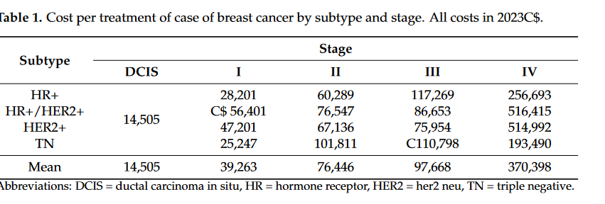
Jurisdictional Review for Self-Referral at 40
Seven jurisdictions have policies in place to allow self-referral. British Columbia, Nova Scotia, Prince Edward Island, and Yukon provide women with the option to self-refer at 40. In Alberta, women can self-refer at 45 or after the first screening in their 40’s. New Brunswick will begin self-referral at 40 in early 2024 and Ontario will begin in the fall of 2024. Manitoba lags behind the majority of jurisdictions.
Jurisdictional Review for Supplemental Screening for Women with Dense Breasts
Province | What is being offered
BC | Ultrasound for Category C and D available with a requisition
AB, NWT | Ultrasound for Category C and D with a requisition  -Screening program published clinical practice recommendation for 2022 for supplemental screening for Category D
ON | Ultrasound for Category C and D available with a requisition  Official recommendation Dec 2023 from ON Health for supplemental screening for Category D. Category C will still be able to access with a requisition.
QC | Ultrasound for Category C and D available with a requisition  -Official recommendation from screening program for Cat D with family history
PEI | Commitment for Category D by Premier-not yet implemented
NB, SK | Access depends on family doctor, location and woman’s ability to advocate for herself
NS, YT | No supplemental screening offered
What the Government of Manitoba can do
The government must ensure that all women can self-refer for a mammogram at 40. The government must also ensure that additional screening is available for women who have dense breasts.
All Manitobans should be given the same opportunity as individuals in other provinces to detect breast cancer early. Finding breast cancer early should not depend on where we live.

