The need for supplemental screening for Nova Scotia women with dense breasts
We are writing about an issue impacting the health and well-being of women in Nova Scotia. Women with dense breasts cannot access essential supplementary screening in Nova Scotia.
Background: In 2019, Nova Scotia began to directly inform women of their breast density category: A, B, C, or D after their screening mammogram. Women can learn if they have dense breasts (category C or D). The NS screening program recognizes there are two risks of dense breasts: “Evidence has shown that having dense breasts is associated with an increased risk of developing breast cancer and dense breast tissue can make it more difficult to detect breast cancer on a mammogram.” Despite these two risks, women cannot access the additional screening they need. It has been known since the 1970s that mammograms are less accurate for women with dense breasts; dense tissue appears white on imaging as does cancer, creating a masking effect. Up to 50% of cancers present in the densest breasts may be missed. Mammography is not enough to ensure cancer is found early.
Issue: As a result of the two risks described above, women with dense breasts are not average risk. Their risk is even higher than a woman with a first degree relative with breast cancer. However, their risk is not sufficiently recognized since they are being denied additional screening. As of 2023, only women in Category D are offered annual instead of biennial mammography for their elevated risk; 50% of cancers are missed in Category D with mammography. Cancer that is missed often results in interval cancers (cancer detected in between regular screenings) and these cancers result in larger tumours and cancer cells that metastasize.
Why are women with dense breasts not being provided with screening ultrasound?
The screening program states there is insufficient evidence to show ultrasound reduces deaths. This is not accurate.
1: To assess mortality reduction, a Randomized Control Trial (RCT) is needed. Mammography is the only screening test proven to reduce deaths from breast cancer because it is the only modality with a completed RCT. No RCT has yet been completed on ultrasound.
2: However, there is one RCT underway in Japan (began 2007 and takes decades). J-Start has shown a 50% reduction in interval cancers. The reduction of interval cancers is accepted as a surrogate for mortality reduction. Interval cancers are 13–18 times more likely in Category D breasts than in the non-dense Category A. If forced to wait for the J-Start trial to mature, countless women will experience avoidable suffering and death from advanced cancers.
3: By focusing only on mortality reduction, the screening program is ignoring all the other benefits of finding cancer early related to quality of life. An early-stage breast cancer may decrease the need for toxic chemotherapy and mastectomy, and reduce women’s suffering.
4: It has been known since 1995 when the Journal Cancer published the first paper that ultrasound detects small, invasive, node-negative cancers in women with dense breasts that were missed on mammograms. Multiple observational studies followed in these past decades and they have shown that when women with dense breasts are offered supplemental screening, many cancers are found before they reach an advanced stage. These are the cancers that will lead to a reduction in mortality and suffering.
5. In December 2023, Ontario Health Technology Advisory Committee published a report and recommendation for supplemental screening after completing an evidence review, costs analysis and patient interviews. The committee acknowledged that the evidence showed that supplemental screening for people with dense breasts detects more cases of breast cancer and leads to fewer interval cancers. The report’s findings also show that supplemental screening led to gains in life-years or quality-adjusted life-years, and to savings in cancer management costs.
Costs of Breast Cancer Treatment
As a result of new treatments and higher survival rates, the costs of treating women with later stage breast cancer have risen significantly. Recently, Canadian researchers found that treating stage 4 breast cancer can cost over $500,000 per patient, depending on the subtype. This equates to treatment that is 11x more expensive than treating stage 1. The 2023 figures can be found here.
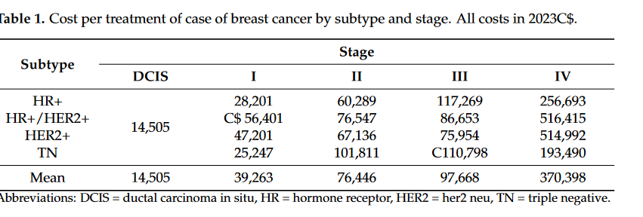
Jurisdictional comparison
Province | Access to supplemental screening for women with dense breasts
BC | Ultrasound for Category C and D is available with a requisition
AB, NWT | Ultrasound for Category C and D is available with a requisition  Screening program published recommendation in 2022 for supplemental screening for Category D
ON | Ultrasound for Category C and D is available with a requisition  Official recommendation in 2023 for supplemental screening for Category D.  Category C will still be able to access with a requisition.
QC | Ultrasound for Category C and D is available with a requisition  Screening program recommendation for supplemental screening for Cat D with family history
PEI | Commitment for Category D by Premier-not yet implemented
NB, SK,  NL, MB | Access depends on family doctor, location
YT | No supplemental screening available
NS | No supplemental screening allowed by screening program -only province where women are denied

What the Government of Nova Scotia can do
In 2019, medical advisor Dr Sian Iles stated at the press conference announcing density notification, “We have been very aware of breast density for many years as radiologists and we've recognized its importance.” However, recognizing the importance of dense breasts means more than just telling women their category and then leaving them without essential additional screening. The government must ensure that screening ultrasound or MRI is accessible so that women in Nova Scotia have a chance to find breast cancer early.

